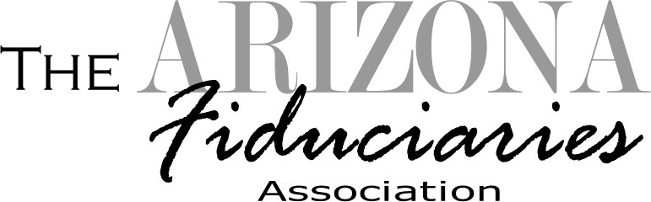

2020 Call for Fiduciary Star Award Nominees

Every year, AFA recognizes special individuals for their outstanding contributions and/or accomplishments. This year, awards will be presented during the Fall Workshop at the
High Country Conference Center in Flagstaff, AZ. Awards will be presented at the
Awards Lunch on Friday, October 23, 2020.

Nominations will be accepted in the following categories:

FIDUCIARY OF THE YEAR STAR AWARD
The Arizona Fiduciaries Association, Inc. (AFA) seeks to recognize a member who has gone above and beyond in practice and representing the fiduciary profession.

RISING FIDUCIARY STAR AWARD
The Arizona Fiduciaries Association, Inc. (AFA) seeks to recognize a licensed fiduciary in their first few years, who is showing promise or exemplary service.

LIFETIME ACHEIVEMENT/RETIRING FIDUCIARY STAR AWARD
The Arizona Fiduciaries Association, Inc. (AFA) would like to recognize those fiduciaries retiring from the industry who have demonstrated a long-standing commitment and made a difference in the fiduciary community.

HOW TO APPLY:
A nomination form is required for consideration by the AFA board. The person making the nomination need not be a member, but the nominee must be a member as of the date the nomination is received and date of the conference, at which the presentation will be made. Please complete the form in its entirety including signature and return by the deadline date. Nominations will be accepted by the AFA Executive Director for consideration by the Board of Directors. The decisions are final. Please submit nomination forms no later than August 30, 2020 to:

Arizona Fiduciaries Association (AFA)
c/o The Carlson Group, LLC
8987 E Tanque Verde #309-125
Tucson, AZ 85749
F: 814.286.3953
execdirector@azfid.org
https://azfid.org

Questions? Contact Pam Carlson at 520.338.0840
2020 AFA Star Award Nomination Application Form
Deadline to Apply: August 30, 2020

I would like to nominate: _________________________________________________
(as it should appear on the award)
for (please check one):

__ FIDUCARY OF THE YEAR STAR AWARD

The Arizona Fiduciaries Association, Inc. (AFA) seeks to recognize a member who has gone above and beyond in practice and representing the fiduciary profession.

__ RISING STAR AWARD

The Arizona Fiduciaries Association, Inc. (AFA) seeks to recognize a licensed fiduciary in their first few years, who is showing promise or exemplary service.

__ LIFETIME ACHEIVEMENT STAR/RETIRING FIDUCIARY

The Arizona Fiduciaries Association, Inc. (AFA) would like to recognize those fiduciaries retiring from the industry who have demonstrated a long-standing commitment and made a difference in the fiduciary community.

Description of the Contributions Demonstrated by Nominee:

For Retiring Nominees:
How Long in Practice: Date of Retirement: Fiduciary Companies Worked For:

Name of Person Making Nomination:
Signature: Date:

